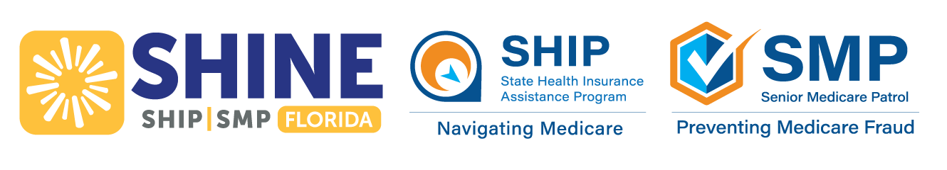
February 2026 Webinar Schedule & Information
SHINE (Serving Health Insurance Needs of Elders) will be hosting virtual classes
for anyone interested in learning more about Medicare.
Class Options | Date | Day | Time (EST) | Register
Medicare Basics  Learn about the different parts of Medicare including Parts A, B, C, D, Medigap, and available financial assistance. | Thursday | February 5 | 12:00PM | Register in advance for this webinar:  https://us02web.zoom.us/webinar/register/WN_h77ZJJzTTJCrOs4z28a7Xg
Medicare Coverage of  Preventive Services  Are you up to date on your Medicare preventive services? Learn more about what Medicare covers. | Tuesday | February 10 | 12:00PM | Register in advance for this webinar:  https://us02web.zoom.us/webinar/register/WN_TkNLvlMOQWCbDSl-DGE5cQ
Medicare Part C + Medicare Advantage Open Enrollment Period  Learn about Medicare Advantage Plan costs and  coverage as well as the opportunity to change coverage during the  MA-OEP from January – March 2026. | Wednesday | February 18 | 12:00PM | Register in advance for this webinar:  https://us02web.zoom.us/webinar/register/WN_8KhCwuCvTZ2Ot934iZ6Anw
Medicare Part D  Learn about Part D costs and coverage. | Tuesday | February 24 | 12:00PM | Register in advance for this webinar:  https://us02web.zoom.us/webinar/register/WN_2Yiekeu5RFibeS2KTxNKpA
If you are not receiving this handout electronically, you can visit www.aaaswfl.org to learn about
and register for upcoming webinars.

Medicare Advantage Open Enrollment Period (MA-OEP)
January 1 – March 31
Did you know that Medicare Advantage plans have their own enrollment period? If you are dissatisfied with your current Advantage plan, you have a single opportunity to switch to a new plan during the first quarter every year.
To learn more, join SHINE on Wednesday, February 18 as we talk in-depth about Part C as well as the option to
change coverage by March 31.

Local Help Navigating Medicare
SHINE counselors are available Monday – Friday to assist you with the Medicare Advantage Open Enrollment and all matters related to Medicare, such as preventive services, cost-saving programs, and identifying and reporting Medicare fraud. SHINE services are confidential, free, and unbiased.

To learn more about the SHINE program or Area Agency on Aging for Southwest Florida, visit:
www.floridashine.org or www.aaaswfl.org



