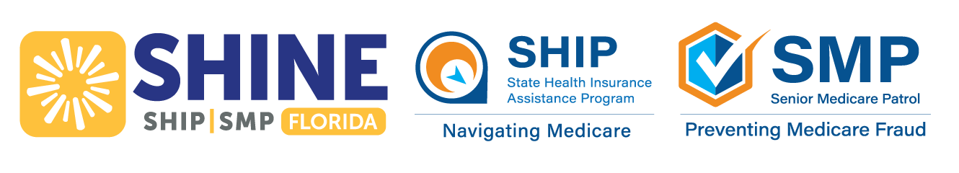
December 2025 Webinar Schedule & Information
SHINE (Serving Health Insurance Needs of Elders) will be hosting virtual classes
for anyone interested in learning more about Medicare.
Class Options | Date | Day | Time (EST) | Register
Senior Medicare Patrol (SMP) – Medicare Fraud & Abuse  Learn how to prevent, detect, and report health care fraud, errors, and abuse. We'll discuss the latest Medicare scams to be aware of. | December 4 | Thursday | 12:00PM | Register in advance for this webinar:  https://us02web.zoom.us/webinar/register/WN_CnpH2wJSSpSWRYWFmGJmNg
Medicare 101  Turning 65 or newly eligible for Medicare? Join SHINE to learn about the basics of Medicare and the importance of enrollment periods. | December 10 | Wednesday | 12:00PM | Register in advance for this webinar:  https://us02web.zoom.us/webinar/register/WN_o4qNH4cFR3qAc3TIUaIAqg
Medicare Financial Assistance  Learn about cost-saving programs to help pay for out-of-pocket health and prescription drug costs. | December 16 | Tuesday | 12:00PM | Register in advance for this webinar:  https://us02web.zoom.us/webinar/register/WN_Gfw-NjOfQRu-8UOcn-0jOA
If you are not receiving this handout electronically, you can visit www.aaaswfl.org to learn about
and register for upcoming webinars.

Medicare’s Open Enrollment Period ends December 7
Don’t miss this important opportunity! Take time to consider your options, SHINE can help you make an informed
decision in choosing the coverage that best fits your needs in 2026.
Throughout open enrollment, SHINE is offering in-person Medicare Counseling Events. Walk-in only (no appointments). To locate an event in your county, visit www.aaaswfl.org (events) or
call the Helpline at 866-413-5337.
If you are unable to attend an event, other counseling options are available.

Local Help Navigating Medicare
SHINE counselors are available Monday – Friday to assist you with Medicare’s Open Enrollment and all matters related to Medicare, such as preventive services, cost-saving programs, and identifying and reporting Medicare fraud.
SHINE services are confidential, free, and unbiased.

To learn more about the SHINE program or Area Agency on Aging for Southwest Florida, visit:
www.floridashine.org or www.aaaswfl.org



