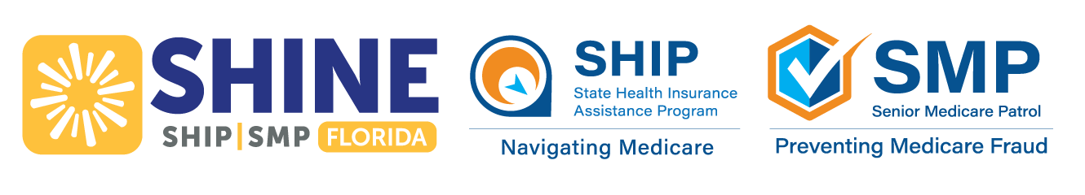
November 2025 Webinar Schedule & Information
SHINE (Serving Health Insurance Needs of Elders) will be hosting virtual classes
for anyone interested in learning more about Medicare.
Class Options | Date | Day | Time (EST) | Register
Medicare Parts C and D  Learn about Medicare Advantage Plan and Part D costs and  coverage plus important changes for 2026.  Medicare’s Open Enrollment Period  ends December 7. | November 7 | Friday | 12:00PM | Register in advance for this webinar:  https://us02web.zoom.us/webinar/register/WN_P0t9Gu_VR7KQicrCtSuFhg
Medicare Basics  Learn about the different parts of Medicare including Parts A, B, C, D, Medigap, and available financial assistance. | November 21 | Friday | 12:00PM | Register in advance for this webinar:  https://us02web.zoom.us/webinar/register/WN_5ywUABBGQfeIP4diYYNuLQ
If you are not receiving this handout electronically, you can visit www.aaaswfl.org to learn about
and register for upcoming webinars.

Medicare’s Open Enrollment Period ends December 7
Don’t miss this important opportunity! Take time to consider your options, SHINE can help you make an informed
decision in choosing the coverage that best fits your needs in 2026.
Throughout open enrollment, SHINE is offering in-person Medicare Counseling Events. Walk-in only (no appointments). To locate an event in your county, visit www.aaaswfl.org (events) or
call the Helpline at 866-413-5337.
If you are unable to attend an event, other counseling options are available.

Local Help Navigating Medicare
SHINE counselors are available Monday – Friday to assist you with Medicare’s Open Enrollment and all matters related to Medicare, such as preventive services, cost-saving programs, and identifying and reporting Medicare fraud.
SHINE services are confidential, free, and unbiased.

To learn more about the SHINE program or Area Agency on Aging for Southwest Florida, visit:
www.floridashine.org or www.aaaswfl.org



