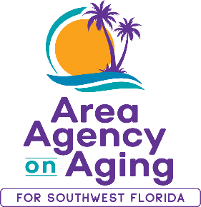

August 12, 2025
**MEDIA ALERT / EVENT**

Free Arthritis-Friendly Exercise Program Launches in Naples with
Special Kickoff Event at HSS at NCH

WHAT: Area Agency on Aging for Southwest Florida (AAASWFL), a nonprofit serving older adults and adults with disabilities, in partnership with HSS at NCH, invites the public to a special kickoff of the Arthritis Foundation Exercise Program (AFEP), a free evidence-based fitness series designed for adults 60+ living with arthritis, stiffness and joint pain.

WHEN: Saturday, September 27, 2025
Kickoff event begins at 8:45 a.m.

Regular classes run Saturdays, 9:00–9:45 a.m.,
from September 27, 2025, to January 17, 2026

No classes on November 29 and December 27

WHERE: HSS at NCH
11190 Health Park Blvd, Building 2
Naples, FL 34110

KICKOFF HIGHLIGHTS:

- Welcome remarks by Lauren Riccardi, Director of Rehabilitation Services
- Interactive activities:
  - DARI Motion Tracker tutorial with personalized printout
  - Light exercise demo on the anti-gravity treadmill
- Program overview presented by AAASWFL

WHY: AFEP classes help reduce arthritis pain and stiffness, increase flexibility, build muscle around joints and boost energy. Exercises are gentle and can be done sitting or standing.

TO REGISTER: Contact Gloria Longoria at 239-652-6914.

MEDIA CONTACT:

Teresa Estefan
EvClay Public Relations
305-261-6222 | teri@evclay.com

About Area Agency on Aging for Southwest Florida:
The Area Agency on Aging for Southwest Florida is a nonprofit organization serving Charlotte, Collier, DeSoto, Glades, Hendry, Lee, and Sarasota Counties. AAASWFL is the state's designated Aging and Disability Resource Center for Southwest Florida. The organization is committed to connecting older adults and adults with disabilities to resources and assistance for living safely with independence and dignity. More information is available at https://www.aaaswfl.org or by calling the toll-free Helpline at 866-41-ELDER.

