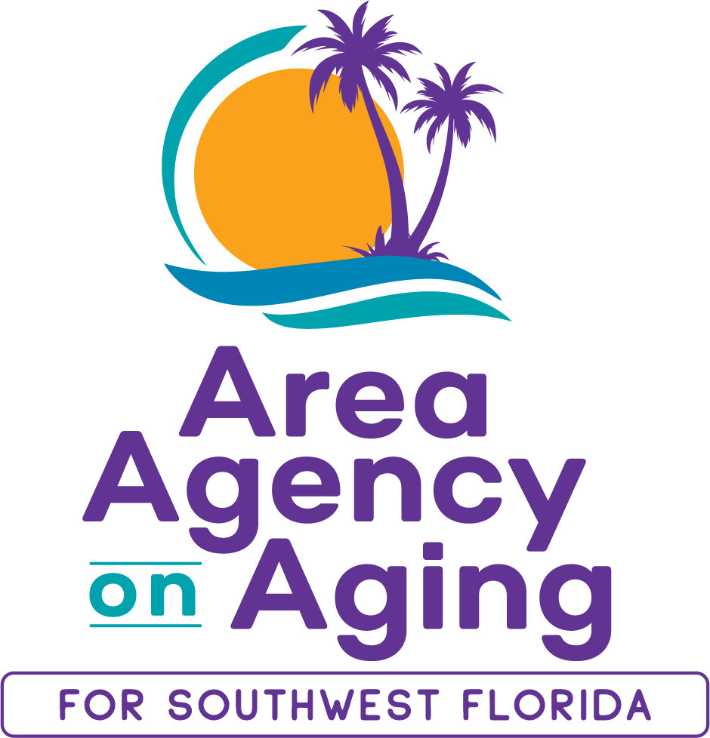 | Clorivel Lappost  Elder Abuse Prevention Coordinator  Area Agency on Aging for SW Florida  2830 Winkler Avenue, Suite 112  239-652-6914  clorivel.lappost@aaaswfl.org

Counties: Charlotte, Collier, DeSoto, Glades, Hendry, Lee, Sarasota

Public Service Announcement: Scam Alert – Skimming at ATMs

February 19, 2025

Recently, several financial institutions in the Tallahassee area have reported finding skimming devices on some of their ATMs. Regardless of where you live, it is important to understand what skimming is and how to protect yourself from it.

According to the Federal Bureau of Investigation (FBI), skimming occurs when devices illegally installed on or outside ATMs, point-of-sale (POS) terminals, or fuel pumps capture card data and record cardholders’ PIN entries. Criminals use the collected data to create fake payment cards and then make unauthorized purchases or steal from victims’ accounts.

The attached United States Secret Service (USSS) flyer includes advice on mitigation and prevention for individual cardholders as follows:

“Immediately contact the card issuer’s fraud department to report the incident, ask that the card be deactivated, and ask that a new card be issued with a new PIN. Monitor the affected account closely. If you suffered a financial loss as a result of the skimming incident, consider filing a fraud affidavit with the card issuer and contacting your local law enforcement agency to report the incident. In the future, consider making purchases using cards which can transact through contactless payment (i.e., tap-to-pay) or with the card’s new EMV chip, instead of the magnetic strip.”

Please see the links below from the USSS and FBI, which provide useful information about skimming, the various types of skimming scams, and tips on how to protect yourself.

https://www.secretservice.gov/investigations/skimming

https://www.fbi.gov/how-we-can-help-you/scams-and-safety/common-frauds-and-scams/skimming

A Public Service Announcement from the Area Agency on Aging for Southwest Florida, Inc., the state-designated disability and aging resource center for Charlotte, Collier, Desoto, Glades, Hendry, Lee and Sarasota counties funded in part by the State of Florida Department of Elder Affairs.

About the Area Agency on Aging for Southwest Florida
The Area Agency on Aging for Southwest Florida is a 501(c)3 organization serving Charlotte, Collier, DeSoto, Glades, Hendry, Lee, and Sarasota Counties. AAASWFL has been operating for 45+ years to provide information and referrals, screening and assessment for Long-Term Care programs, and Medicare counseling. More information is available by visiting the AAASWFL website (www.aaaswfl.org) or by calling the Helpline: (866) 413-5337.

