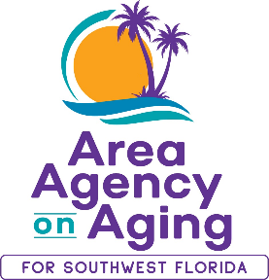

**Media Contact:**

Teresa Estefan

EvClay Public Relations

305-261-6222

[teri@evclay.com](mailto:teri@evclay.com)

**Area Agency on Aging for SWFL Launches a**

**Long-Term Hurricane Ian Recovery Assistance Program in Lee County**

**FORT MYERS, Florida—January 23, 2025—** The [**Area Agency on Aging for Southwest Florida**](https://aaaswfl.org/) (AAASWFL) has been awarded a micro-grant from the Lee County Unmet Needs Long Term Recovery Group (UNLTRG) to help provide ongoing support to older adults and adults with disabilities in Lee County with unmet needs associated with Hurricane Ian.

“We are very grateful for the opportunity to continue supporting clients in recovery from Hurricane Ian,” shares Sarah Gualco, AAASWFL Director of Programs.

Recovery from a major disaster such as Hurricane Ian is a process that can take years. Seniors and adults with disabilities can be especially vulnerable and often face unique challenges, making their recovery even more difficult. AAASWFL is committed to helping seniors and adults with disabilities rebound from their losses and sustain their physical, social, economic, and emotional well-being.

The disaster assistance process can be difficult to navigate. In her new role as Disaster Assistance Coordinator, Patti Teel will help Lee County residents who are still working to recover from Hurricane Ian. She will assess eligibility for local assistance, connect individuals with matching recovery programs and provide application assistance upon request.

To qualify for this assistance, you must be a Lee County resident age 60+ or age 18+ with a disability. To learn more, call our helpline at **866-413-5337** and ask about our Hurricane Ian Disaster Assistance Program.

**About the Area Agency on Aging for Southwest Florida**

The Area Agency on Aging for Southwest Florida is a 501(c)3 organization serving Charlotte, Collier, DeSoto, Glades, Hendry, Lee, and Sarasota Counties. AAASWFL has been operating for 45+ years to provide information and referrals, screening and assessment for Long-Term Care programs, and Medicare counseling. More information is available by visiting the AAASWFL website (www.aaaswfl.org) or by calling the Helpline: (866) 413-5337.