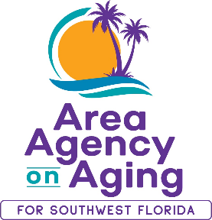

**Media Contact:**

Teresa Estefan

EvClay Public Relations

305-261-6222

[teri@evclay.com](mailto:teri@evclay.com)

**Area Agency on Aging for SWFL Joins National Campaign to**

**Protect Older Adults from Financial Scams**

**Southwest Florida —December 19, 2024—** To help older adults stay safe this holiday season, the Area Agency on Aging for Southwest Florida is participating in Home for the Holidays, a national campaign led by the Eldercare Locator and USAging. This year’s campaign provides guidance to older adults, caregivers and families on avoiding financial scams and fraud.

Scams targeting people aged 60 and older resulted in over $3.4 billion in losses in 2023 alone, according to the FBI. Although financial scams can occur throughout the year, they usually increase around the holiday season due to increased online shopping or donations. Older adults, especially those who are isolated or lonely, are particularly vulnerable.

A new Home for the Holidays brochure, [**Protect Your Wallet: A Guide to Avoiding Financial Scams**](https://www.usaging.org/Files/EL-Home-4-Holidays%2024_508.pdf), highlights common scams that target older adults, tips for avoiding scams and resources for reporting them. This year’s campaign empowers older adults to take control of their finances and avoid falling victim to the fraudsters that prey on them.

“We’re committed to helping older adults in Southwest Florida live safely with independence and dignity. Empowering our community with resources that can help them avoid fraud and financial scams is an important aspect of our mission,” Clorivel Lappost, Health and Wellness and Elder Abuse Coordinator.

If you need help identifying financial scams, the Area Agency on Aging for SWFL can help. Call our helpline 866-413-5337 or visit [aaaswfl.org](https://aaaswfl.org/) to learn more.

**About the Area Agency on Aging for Southwest Florida**

The Area Agency on Aging for Southwest Florida is a 501(c)3 organization serving Charlotte, Collier, DeSoto, Glades, Hendry, Lee, and Sarasota Counties. AAASWFL has been operating for 45+ years to provide information and referrals, screening and assessment for Long-Term Care programs, and Medicare counseling. More information is available by visiting the AAASWFL website (www.aaaswfl.org) or by calling the Helpline: (866) 413-5337.