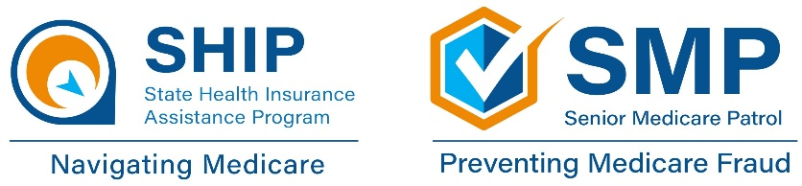

May 2024 Webinar Schedule & Information
SHINE (Serving Health Insurance Needs of Elders) will be hosting virtual classes
for anyone interested in learning more about Medicare.
Class Options | Date | Day | Time (EST) | Register
Medicare 101  Join SHINE, learn about the basics of Medicare and the importance of enrollment periods. | May 8 | Wednesday | 10:00AM | Register in advance for this webinar:  https://us02web.zoom.us/webinar/register/WN_WxORJpjWRkCoC6TH48-RbA
Medicare Part C  Join SHINE, learn about Medicare Advantage Plan costs and  coverage. | May 16 | Thursday | 12:00PM | Register in advance for this webinar:  https://us02web.zoom.us/webinar/register/WN_t8PqUWERRzKZVQddX9IoFg
Medicare Part D  Join SHINE, learn about Part D costs and coverage. | May 23 | Thursday | 12:00PM | Register in advance for this webinar:  https://us02web.zoom.us/webinar/register/WN_CyEeyKcLR1GNopCyj-pF9g
Medicare Financial Assistance  Join SHINE, learn about cost-saving programs to help pay for  out-of-pocket health and prescription drug costs. | May 29 | Wednesday | 12:00PM | Register in advance for this webinar:  https://us02web.zoom.us/webinar/register/WN_RdLzEl1dQBmfeQIpTnTwoQ

If you are not receiving this handout electronically, you can visit www.aaaswfl.org to learn about
and register for upcoming webinars.

Local Help Navigating Medicare
SHINE trained counselors are available year-round Monday – Friday to assist you with all matters related to Medicare,
including access to preventive services, cost-saving programs, and identifying
and reporting Medicare fraud. SHINE services are confidential, free, and unbiased.

To request SHINE counseling, call the Helpline at 866-413-5337. To learn more about the SHINE program or
Area Agency on Aging for Southwest Florida, visit:
www.floridashine.org or www.AAASWFL.org

