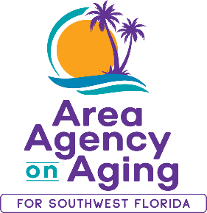 | 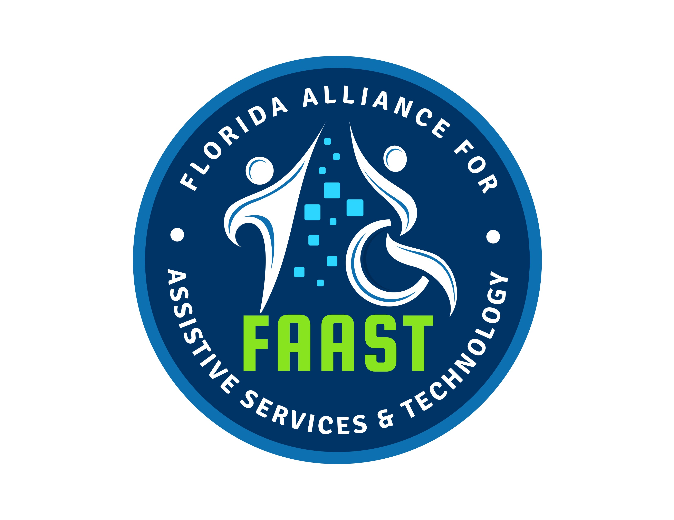  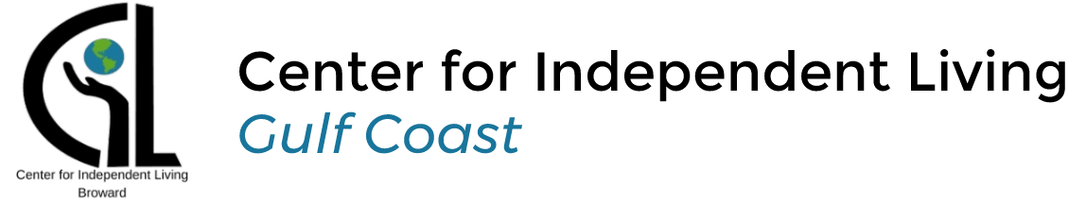

February 15, 2024
**MEDIA ALERT**

AREA AGENCY ON AGING FOR SWFL HOSTS FREE BINGO EVENTS
In Collaboration with Center for Independent Living Gulf Coast and Florida Alliance for Assistive Services & Technology Southwest

WHAT: Area Agency on Aging for Southwest Florida (AAASWFL) will be partnering with the Center for Independent Living Gulf Coast and Florida Alliance for Assistive Services & Technology Southwest to host three BINGO events in March. These events are open to older adults (60+) and adults with disabilities (18+). BINGO will be called in both English and Spanish to accommodate all participants. Winners will receive prizes. Seating is limited to the first thirty registered individuals, so secure your spot now by registering at BINGO Registration.

WHEN: Friday, March 8, 2024
Wednesday, March 27, 2024
Friday, March 29, 2024

1:00 p.m. – 3:00 p.m.

WHERE: Area Agency on Aging for Southwest Florida
2830 Winkler Avenue, Suite 112
Fort Myers, FL 33916

WHO: Free for older adults (60+) and adults with disabilities

About Area Agency on Aging for Southwest Florida:
Area Agency on Aging for Southwest Florida is a nonprofit organization serving Charlotte, Collier, DeSoto, Glades, Hendry, Lee and Sarasota counties. AAASWFL is the state's designated Aging and Disability Resource Center for Southwest Florida. The organization is committed to connecting older adults and adults with disabilities to resources and assistance for living safely with independence and dignity. More information is available at https://www.aaaswfl.org or by calling the toll-free Helpline at 866-41-ELDER.

