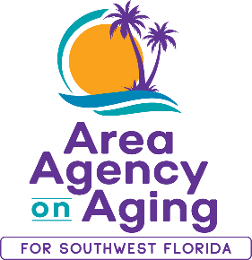 | 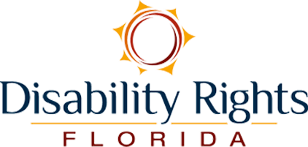

February 1, 2024
**MEDIA ALERT**

AREA AGENCY ON AGING HOSTS FREE COVID-19 AND FLU VACCINE CLINIC
In Collaboration with Disability Rights Florida

WHAT: Area Agency on Aging for Southwest Florida (AAASWFL) will be partnering with Disability Rights Florida to organize a no-cost clinic for COVID-19 and flu vaccines. This clinic is scheduled for the morning of Friday, February 16th, and will offer both Moderna COVID-19 and flu vaccines to older adults (60+), and adults with disabilities. To secure a spot, individuals can register in advance through the provided link: AAASWFL 2024 Vaccine Clinic Registration - Smartsheet.com. Additionally, AAASWFL will be handing out gift cards to the first 15 individuals who sign up and receive a vaccine.

WHEN: Friday, February 16, 2024

9:00 a.m. to 12:00 p.m. (noon)

WHERE: Area Agency on Aging for Southwest Florida
2830 Winkler Avenue, Suite 112
Fort Myers, FL 33916

Main Conference Room

WHO: Free for older adults (60+), and adults with disabilities

About Area Agency on Aging for Southwest Florida:
Area Agency on Aging for Southwest Florida is a nonprofit organization serving Charlotte, Collier, DeSoto, Glades, Hendry, Lee and Sarasota counties. AAASWFL is the state's designated Aging and Disability Resource Center for Southwest Florida. The organization is committed to connecting older adults and adults with disabilities to resources and assistance for living safely with independence and dignity. More information is available at https://www.aaaswfl.org or by calling the toll-free Helpline at 866-41-ELDER.

