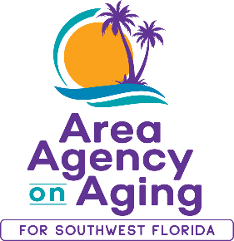 | Media Contact:  Teresa Estefan  EvClay Public Relations for  Area Agency on Aging for SWFL  teri@evclay.com  305-261-6222

AREA AGENCY ON AGING FOR SW FLORIDA
BOARD OF DIRECTOR OPPORTUNITIES
Help make a difference in the lives of older adults and adults with disabilities!

FORT MYERS, Fla. — February 6, 2024 —The Area Agency on Aging for Southwest Florida (AAASWFL), a nonprofit organization serving older adults and adults with disabilities in Charlotte, Collier, DeSoto, Glades, Hendry, Lee and Sarasota counties, is seeking volunteers to serve as members on their Board of Directors. The organization is committed to connecting older adults and adults with disabilities to resources and assistance for living safely with independence and dignity.

Potential board members must be 60-years or older, residents of Glades, DeSoto, Sarasota, Collier and Hendry counties, and a representative working in or retired from banking, faith-based organizations, mental health, or physical therapy.

Individuals interested in applying to sit on the Area Agency on Aging’s board of directors or seeking other volunteer opportunities can visit https://aaaswfl.org/how-to-help/volunteer/ to learn more.

About Area Agency on Aging for Southwest Florida:
Area Agency on Aging for Southwest Florida is a nonprofit organization serving Charlotte, Collier, DeSoto, Glades, Hendry, Lee and Sarasota counties. AAASWFL is the state's designated Aging and Disability Resource Center for Southwest Florida. The organization is committed to connecting older adults and adults with disabilities to resources and assistance for living safely with independence and dignity. More information is available at https://www.aaaswfl.org or by calling the toll-free Helpline at 866-41-ELDER.

