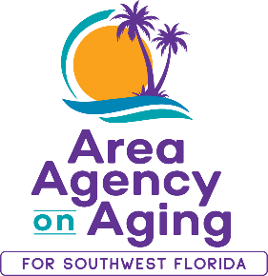 | Media Contact:  Teresa Estefan  EvClay Public Relations for  Area Agency on Aging for SWFL  teri@evclay.com  305-261-6222

FOR IMMEDIATE RELEASE
November 1, 2023
Statewide Program Provides Free, Unbiased Insurance Counseling
for Medicare Beneficiaries
Older Floridians are encouraged to review plan options during Open Enrollment

Southwest Florida – The Area Agency on Aging for Southwest Florida (AAASWFL) is reminding residents that their Serving Health Insurance Needs of Elders (SHINE) program has specifically-trained counselors to help educate and empower Medicare beneficiaries, their families, and caregivers to understand their health care options so they can make the best decisions for their individual needs during the Open Enrollment period. During open enrollment, beneficiaries can change their Medicare Prescription Drug or Medicare Advantage plan to effect things like cost, coverage, drug formularies, in-network providers, and pharmacies.

“Medicare can be a daunting subject for most people and the Open Enrollment Period only runs from Oct. 15, 2023, through Dec. 7, 2023, but you don’t have to go it alone! During this time, lean on our experts for advice and utilize a local, valuable resource by connecting with the SHINE program,” said Maricela Morado, president and CEO, Area Agency on Aging for SWFL.

SHINE is a program of the Florida Department of Elder Affairs and is operated locally through the Area Agency on Aging for Southwest Florida. The SHINE mission is to provide free and unbiased information about Medicare and Medicaid for beneficiaries, their families, and caregivers. SHINE also educates beneficiaries to protect, detect, and report potential errors, fraud, and abuse with their Medicare coverage. SHINE strongly encourages beneficiaries to be on the lookout for their Annual Notice of Change (ANOC), which they should receive from their plan no later than Sept. 30, 2023. Reviewing their benefits and evaluating their health care options each year is vitally important for beneficiaries. Acting quickly can assure a smooth transition into the 2024 benefit year.

To receive help from SHINE, individuals may call to schedule appointments at designated SHINE counseling sites, attend enrollment events in their local communities, or arrange to speak with a trained SHINE counselor at 866-413-5337. For a listing of SHINE counseling sites and enrollment events, please visit www.floridashine.org.

About Area Agency on Aging for Southwest Florida:
Area Agency on Aging for Southwest Florida is a nonprofit organization serving Charlotte, Collier, DeSoto, Glades, Hendry, Lee and Sarasota counties. AAASWFL is the state's designated Aging and Disability Resource Center for Southwest Florida. The organization is committed to connecting older adults and adults with disabilities to resources and assistance for living safely with independence and dignity. More information is available at https://www.aaaswfl.org or by calling the toll-free Helpline at 866-41-ELDER.

