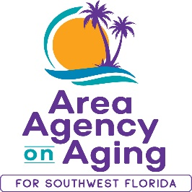
FOR MORE INFORMATION, CONTACT:
Patti Teel
Hurricane Ian Outreach Coordinator
239-652-6921
patti.teel@aaaswfl.org

FOR IMMEDIATE RELEASE
10/30/2023
Still Recovering from Hurricane Ian?
The Area Agency on Aging for SWFL Can Provide Assistance to Those Still Struggling with Impact from Hurricane Ian.

Southwest, FL (October 30, 2023)— It’s been more than a year since Hurricane Ian made landfall in Southwest Florida, and things are getting better for most people. However, many residents still have unmet needs. Volunteer Florida and Area Agency on Aging for Southwest Florida (AAASWFL) have not forgotten about those still needing assistance. The Volunteer Florida Foundation has granted funds, which are still available through the Area Agency on Aging, for Hurricane Ian response efforts.
Examples of assistance already provided include mobility devices, window repairs, portable air conditioners, appliances, garage door repairs, toilet replacements, floor repairs, and drywall repairs. Those seeking assistance must have exhausted other funding resources and if granted, payment is made directly to the service vendor.
The Area Agency on Aging for Southwest Florida is a nonprofit organization that has served Charlotte, Collier, DeSoto, Glades, Hendry, Lee, and Sarasota Counties for more than 40 years. The organization is committed to connecting older adults (ages 60 and over) and people with disabilities to resources and assistance for living safely with independence and dignity. AAASWFL is the state’s designated Aging and Disability Resource Center for Southwest Florida.
More information is available by visiting the AAASWFL website (www.aaaswfl.org) or by calling the Elder Helpline: (866) 413-5337.

