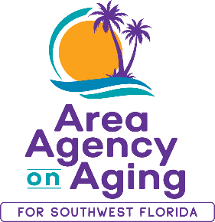 | Media Contact:  Teresa Estefan / Melisa Chantres  EvClay Public Relations for  Area Agency on Aging for SWFL  teri@evclay.com | mmchantres@evclay.com  305-261-6222

STORM UPDATES from the Area Agency on Aging for SWFL

FORT MYERS, Fla. — August 28, 2023 —The Area Agency on Aging for Southwest Florida (AAASWFL) offices will be closed for in-person visits on Tuesday and Wednesday, August 29 and 30, 2023, in preparation for Tropical Storm/Hurricane Idalia.
The AAASWFL team will continue to be available to assist Southwest Florida residents on the phone and over email. The Elder Helpline hours are Monday - Friday, from 8:00 a.m. - 5:00 p.m.. Please call 866-413-5337 OR 866-41-ELDER for assistance.
Valuable resources to help you prepare for an upcoming storm:
- Florida Department of Elder Affairs 2023 Disaster Preparedness Guide
- Disaster Preparedness for Dementia Caregivers Guide by the Alzheimer’s Association and the University of South Florida
AAASWFL will continue to share updates and resources on social media. You can find the Area Agency on Aging for SWFL on Facebook, Twitter, LinkedIn, and Instagram.
Want to know how you can help local seniors in crisis? Donate to the Area Agency on Aging for Southwest Florida! Your contribution will help us continue our work in the community by meeting the known and emerging needs of seniors.

About Area Agency on Aging for Southwest Florida:
Area Agency on Aging for Southwest Florida is a nonprofit organization serving Charlotte, Collier, DeSoto, Glades, Hendry, Lee and Sarasota counties. AAASWFL is the state's designated Aging and Disability Resource Center for Southwest Florida. The organization is committed to connecting older adults and adults with disabilities to resources and assistance for living safely with independence and dignity. More information is available at https://www.aaaswfl.org or by calling the toll-free Helpline at 866-41-ELDER.

