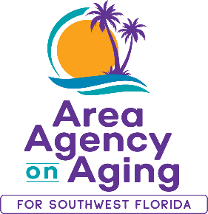 | Media Contact:  Teresa Estefan  EvClay Public Relations for  Area Agency on Aging for SWFL  teri@evclay.com  305-261-6222

AREA AGENCY ON AGING HOSTING ITS FIRST
COMMUNITY HEALTH & RESOURCE FAIR ON SEPTEMBER 15
Part of 45-Year Anniversary Celebration

FORT MYERS, Fla. — August 28, 2023 —The Area Agency on Aging for Southwest Florida (AAASWFL) will be hosting its first Community Health & Resource Fair on Friday, September 15, 2023 as part of its 45-year anniversary serving older adults, adults with disabilities and caregivers in Charlotte, Collier, DeSoto, Glades, Hendry, Lee, and Sarasota counties. The fair runs from 11:00 a.m. to 2:00 p.m. at 2830 Winkler Avenue, Suite 112, Fort Myers, FL 33196.

Who is this fair for?

Everyone is invited to come by and get to know us! Free health screenings, community resources, education, giveaways, and more will be available to older adults age 60+, adults with disabilities, and their families and caregivers. Lunch will be offered thanks to the generosity of sponsors Florida Power & Light and Pacos Tacos.

Screening and Services

- The Alzheimer’s Association’s Brain Bus will be onsite. Trained staff will be available to help families understand steps to an accurate diagnosis, warning signs, caregiving tips and connect to local resources. No appointment is required.
- Balance screenings by Lee Health Rehabilitation will help assess your balance and stability through a simple test, helping to identify any issues that could lead to falls and provide insights into potential corrective measures.
- Stabilized Steps will be conducting balance aid demonstrations in addition to balance screenings.
- Hearing screenings will be provided by Connect Hearing.
- Free Covid vaccines and boosters will be available.
- Free flu shots will also be offered.

To register for this free event, click on the link.

Funds raised will go to assisting older adults and adults with disabilities in crisis when no other resources are available. Donations to support older adults in crisis are welcome, visit https://aaaswfl.org/how-to-help/donate/.

About Area Agency on Aging for Southwest Florida:
Area Agency on Aging for Southwest Florida is a nonprofit organization serving Charlotte, Collier, DeSoto, Glades, Hendry, Lee and Sarasota counties. AAASWFL is the state's designated Aging and Disability Resource Center for Southwest Florida. The organization is committed to connecting older adults and adults with disabilities to resources and assistance for living safely with independence and dignity. More information is available at https://www.aaaswfl.org or by calling the toll-free Helpline at 866-41-ELDER.

