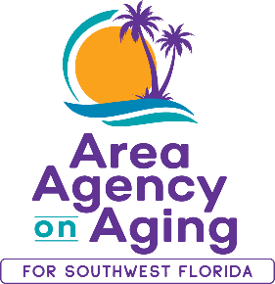 | Media Contact:  Teresa Estefan  EvClay Public Relations for  Area Agency on Aging for SWFL  teri@evclay.com  305-261-6222

AREA AGENCY ON AGING HOSTS COMMUNITY HEALTH & RESOURCE FAIR
On September 15 as Part of 45-Year Anniversary Celebration

FORT MYERS, Fla. — July 12, 2023 —The Area Agency on Aging for Southwest Florida (AAASWFL) is thrilled to announce that it will host its first Community Health & Resource Fair on Friday, September 15, 2023 as part of its celebration of 45 years of dedicated service to the community's older adults, individuals with disabilities and caregivers.

The fair will offer free health screenings, community resources, education and more! It will be held on September 15 from 11:00 a.m. to 2:00 p.m. at the Area Agency on Aging for Southwest Florida located at 2830 Winkler Avenue, Suite 112, Fort Myers, FL 33196.

To register for this free event, click on the link.

This is a great opportunity to connect with members of the community, share services and products, and increase awareness of community resources. All benefit when older adults and adults with disabilities remain engaged, independent and included.

To learn about sponsorship opportunities, please visit https://aaaswfl.org/health-wellness/sep-15-community-health-resource-fair-sponsorship-opportunities/.

The deadline to register for sponsorships is July 25, 2023.

Funds raised will be directed to AAASWFL’s Agnes Laitinen Unmet Needs Crisis Fund. This fund assists older adults and adults with disabilities in crisis when no other resources are available.

About Area Agency on Aging for Southwest Florida:
Area Agency on Aging for Southwest Florida is a nonprofit organization serving Charlotte, Collier, DeSoto, Glades, Hendry, Lee and Sarasota counties. AAASWFL is the state's designated Aging and Disability Resource Center for Southwest Florida. The organization is committed to connecting older adults and adults with disabilities to resources and assistance for living safely with independence and dignity. More information is available at https://www.aaaswfl.org or by calling the toll-free Helpline at 866-41-ELDER.

