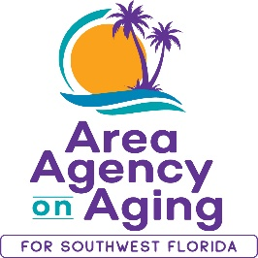

FOR MORE INFORMATION, CONTACT:
Sarah Gualco
239-652-6926

FOR IMMEDIATE RELEASE
03/20/2023

Join the Area Agency on Aging for SWFL for a
Conversation about Aging Services in SWFL

Fort Myers, FL (March 20, 2023)— The Area Agency on Aging for SWFL (AAASWFL) is inviting local residents and service providers to join an On the Table conversation about Aging Services in Lee County. Comments shared will serve to inform AAASWFL’s strategic plan and service goals for the next four years.

On the Table SWFL is a community-wide forum that invites Southwest Floridians to gather to build personal connections and explore how we can work together to make our communities stronger. The AAASWFL On the Table conversation will take place at 2830 Winkler Ave, Suite 112 on Thursday, March 30th, 2pm – 3pm.

For more information or to register your attendance, please call Sarah Gualco at 239-652-6926 or visit AAASWFL On the Table.

The Area Agency on Aging for Southwest Florida is a nonprofit organization that has served Charlotte, Collier, DeSoto, Glades, Hendry, Lee, and Sarasota Counties for more than 40 years. The organization is committed to connecting older adults (ages 60 and over) and people with disabilities to resources and assistance for living safely with independence and dignity. AAASWFL is the state’s designated Aging and Disability Resource Center for Southwest Florida. To contact AAASWFL for service information, call the Elder Helpline at 866-413-5337.

