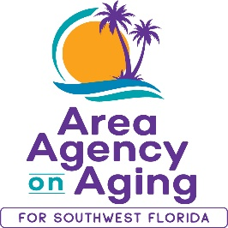

FOR MORE INFORMATION, CONTACT:
Sarah Gualco
239-652-6926

FOR IMMEDIATE RELEASE
03/20/2023

Join the Area Agency on Aging for SWFL for a
Conversation about Aging Services in Hendry County

Hendry County, FL (March 20, 2023)— The Area Agency on Aging for SWFL (AAASWFL) is inviting local residents and service providers in Hendry County to share public comment about Aging Services in SWFL. Comments shared will serve to inform AAASWFL’s strategic plan and service goals for the next four years.

AAASWFL is hosting two Town Hall Meetings in Hendry County. Monday, March 27th, 1:00 – 2:00pm, in LaBelle at Hope Connections: 475 E Cowboy Way, and in Clewiston on Friday, April 7th, 10:00 – 11:00am, at the Janet B. Taylor Auditorium: 1100 S Olympia Street.

The Area Agency on Aging for Southwest Florida is a nonprofit organization that has served Charlotte, Collier, DeSoto, Glades, Hendry, Lee, and Sarasota Counties for more than 40 years. The organization is committed to connecting older adults (ages 60 and over) and people with disabilities to resources and assistance for living safely with independence and dignity. AAASWFL is the state’s designated Aging and Disability Resource Center for Southwest Florida. To contact AAASWFL for service information, call the Elder Helpline at 866-413-5337.
For more information or to register your attendance, please call Sarah Gualco at 239-652-6926.

