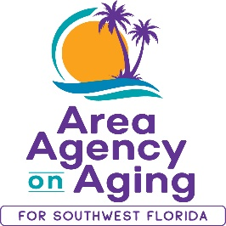

FOR MORE INFORMATION, CONTACT:
Sarah Gualco
239-652-6926

FOR IMMEDIATE RELEASE
03/21/2023

Join the Area Agency on Aging for SWFL for a
Conversation about Aging Services in DeSoto County

DeSoto County, FL (March 21, 2023)— The Area Agency on Aging for SWFL (AAASWFL) is inviting local residents and service providers in DeSoto County to share public comment about Aging Services in SWFL. Comments shared will serve to inform AAASWFL’s strategic plan and service goals for the next four years.

AAASWFL is hosting a Town Hall Meeting on Friday, March 31st, 11:00am – 12:00pm at the Senior Friendship Center in Arcadia: 917 N Arcadia Ave, Arcadia, FL 34266.

The Area Agency on Aging for Southwest Florida is a nonprofit organization that has served Charlotte, Collier, DeSoto, Glades, Hendry, Lee, and Sarasota Counties for more than 40 years. The organization is committed to connecting older adults (ages 60 and over) and people with disabilities to resources and assistance for living safely with independence and dignity. AAASWFL is the state’s designated Aging and Disability Resource Center for Southwest Florida. To contact AAASWFL for service information, call the Elder Helpline at 866-413-5337.
For more information or to register your attendance, please call Sarah Gualco at 239-652-6926.

