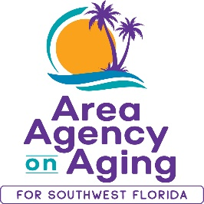
FOR MORE INFORMATION, CONTACT:
Sarah Gualco
Health & Wellness Coordinator
239-652-6914
Sarah.gualco@aaaswfl.org

FOR IMMEDIATE RELEASE
01/04/2023
You Could Change Someone’s Life!
Become a Certified Coach to Lead A Matter of Balance Classes with this FREE Training offered by the Area Agency on Aging for SWFL

Southwest, FL (January 4, 2023)— Chances are you know someone who has fallen or who is afraid of falling. A Matter of Balance is a proven program designed to help people manage concerns about falls and increase physical activity. Area Agency on Aging for Southwest Florida is looking for volunteers to help provide this program.
A Matter of Balance: Managing Concerns About Falls is conducted in 8 two-hour sessions and uses group discussion, problem-solving strategies, videos and gentle physical exercise. Older adults learn positive coping methods to reduce fear of falling and remain active and independent.
A Matter of Balance coaches help participants become more confident about managing falls by believing that they can increase their strength, find ways to reduce falls, and protect themselves if they do fall. In addition, participants report that they have increased the amount they exercise on a regular basis.
A Matter of Balance coaches need good communication and interpersonal skills, enthusiasm, dependability and a willingness to lead small groups of older adults. Coaches also need to be able to lead low to moderate level exercise.
The A Matter of Balance Coach Training will be held virtually via Zoom on Monday, March 6th, and Wednesday, March 8th, from 1pm to 5pm. Space is limited and advance registration is required. To participate, you must reside in Charlotte, Collier, DeSoto, Glades, Hendry, Lee, or Sarasota County. To register, contact Sarah Gualco, AAASWFL’s Health & Wellness Coordinator at sarah.gualco@aaaswfl.org or by calling 239-652-6914.

About Area Agency on Aging for Southwest Florida:
Area Agency on Aging for Southwest Florida is a nonprofit organization serving Charlotte, Collier, DeSoto, Glades, Hendry, Lee, and Sarasota Counties. AAASWFL is the state's designated Aging and Disability Resource Center for Southwest Florida. The organization is committed to connecting older adults and adults with disabilities to resources and assistance for living safely with independence and dignity. More information is available at https://www.aaaswfl.org or by calling the toll-free Helpline at 866-41-ELDER.

