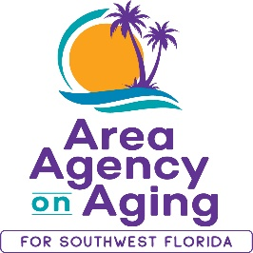
FOR MORE INFORMATION, CONTACT:
Sarah Gualco
Health & Wellness Coordinator
239-652-6914
Sarah.gualco@aaaswfl.org

FOR IMMEDIATE RELEASE
Improve Your Health & Wellness
with a FREE Tai Chi Class!
Tai Chi for Arthritis and for Fall Prevention

Southwest, FL (December 8, 2022)— The Tai Chi for Arthritis for Fall Prevention program was designed to relieve pain, improve balance, and significantly reduce falls. Designed by a team of medical professionals and tai chi experts, the Tai Chi for Arthritis for Fall Prevention program is recommended by the Centers for Disease Control and Prevention (CDC) as an exercise to prevent falls and is supported by arthritis foundations worldwide.
Starting in January, the Area Agency on Aging for SWFL (AAASWFL), will offer free Tai Chi classes in Lee County. Hope Episcopal Church in Bonita Springs will host a class on Mondays and Wednesdays, 10:30am to 11:30am, beginning January 9, 2023. Lake Kennedy Senior Center in Cape Coral will host a class on Tuesdays and Thursdays, 9:00am to 9:45am, beginning February 7, 2023.
Space is limited and advance registration is required. For more information and to register for a class, contact Sarah Gualco, AAASWFL’s Health & Wellness Coordinator at sarah.gualco@aaaswfl.org or by calling 239-652-6914.

