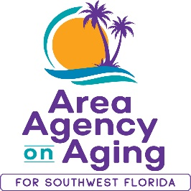
FOR MORE INFORMATION, CONTACT:
Sarah Gualco
Health & Wellness Coordinator
239-652-6914
Sarah.gualco@aaaswfl.org

FOR IMMEDIATE RELEASE
12/16/2022
Free Caregiver Support Program!
Increase Caregiver Knowledge & Skills with this virtual evidence-based workshop offered by the Area Agency on Aging for SWFL

Southwest, FL (December 16, 2022)— Powerful Tools for Caregivers, a six-week, evidence-based program, is designed to assist caregivers in improving: self-care behaviors, self-confidence, and community connections. Over the course of six weeks, participants are coached in proactive ways to deal with the difficult emotions that can often accompany caregiving and are connected to a network of individuals to share support and best practices.
Starting in January, the Area Agency on Aging for SWFL (AAASWFL), will offer a free, virtual six-week Powerful Tools for Caregivers Workshop. This workshop series begins January 24th and continues to February 28th, every Tuesday from 2:00pm to 3:30pm on ZOOM.
Space is limited and advance registration is required. To participate, you must reside in Charlotte, Collier, DeSoto, Glades, Hendry, Lee, or Sarasota County. To register, contact Sarah Gualco, AAASWFL’s Health & Wellness Coordinator at sarah.gualco@aaaswfl.org or by calling 239-652-6914.

