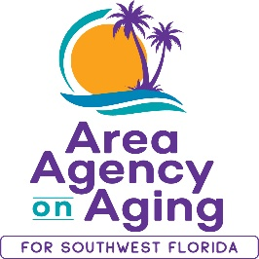
FOR MORE INFORMATION, CONTACT:
Sarah Gualco
Health & Wellness Coordinator
239-652-6914
Sarah.gualco@aaaswfl.org

FOR IMMEDIATE RELEASE
10/27/2022

Free Caregiver Support Program!
Increase Caregiver Knowledge & Skills with this virtual evidence-based workshop offered by the Area Agency on Aging for SWFL

Southwest, FL (October 27, 2022)— Savvy Caregiver, an evidence-based program developed by curriculum authors at Emory University, is a six-week workshop designed to provide caregivers of people with dementia-related illness with the knowledge, skills, and attitudes necessary to manage stress and to execute the caregiving role effectively. Participants will gain personal knowledge and caregiving perspective and will develop skills crucial to assessing the abilities of their person who is living with dementia illness. The workshop focuses on building confidence, setting and altering caregiver goals, and developing strategies to manage the activities of daily living.
Starting on November 14th, the Area Agency on Aging for SWFL (AAASWFL), will offer a free, virtual six-week Savvy Caregiver Workshop. This workshop series begins November 14th and continues to December 19th, every Monday from 11:00am to 1:00pm on ZOOM.
Space is limited and advance registration is required. To participate, you must reside in Charlotte, Collier, DeSoto, Glades, Hendry, Lee, or Sarasota County. To register, contact Sarah Gualco, AAASWFL’s Health & Wellness Coordinator at sarah.gualco@aaaswfl.org or by calling 239-652-6914.

