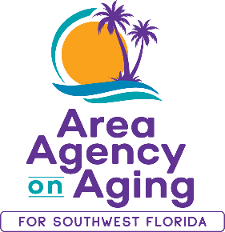 | FOR MORE INFORMATION:  Teresa Estefan  EvClay Public Relations  testefan@evclay.com  305-586-6495

AREA AGENGY ON AGING FOR SOUTHWEST FLORIDA UPDATES
AND EMERGENCY RESOURCES
Learn How to Help Older Adults in SWFL

FORT MYERS, Fla. — October 2, 2022 — The Area Agency on Aging for Southwest Florida (AAASWFL), the state's designated Aging and Disability Resource Center for Southwest Florida, remains closed in the aftermath of Hurricane Ian. Our Elder Helpline, 866-413-5337 or 866-41-ELDER, is being operated by a neighboring Area Agency on Aging during regular hours of operation, Monday through Friday, 8:00 a.m. to 5:00 p.m. Our clients are important to us, especially during this time of need. Voicemail messages will be returned in the order they are received.

To request well-being checks for family members and friends in Lee County, please call 239-477-1000.

The American Red Cross can assist in helping you connect with loved ones at 1-800-733-2767.

You can also visit https://missing.fl.gov/es to report missing individuals.

If you wish to help financially, visit https://aaaswfl.org/how-to-help/donate/. Your donations will go to AAASWFL’s Agnes Laitinen Unmet Needs Fund. This fund assists older adults and adults with disabilities in crisis when no other resources are available.

About Area Agency on Aging for Southwest Florida:
Area Agency on Aging for Southwest Florida is a nonprofit organization serving Charlotte, Collier, DeSoto, Glades, Hendry, Lee, and Sarasota Counties. AAASWFL is the state's designated Aging and Disability Resource Center for Southwest Florida. The organization is committed to connecting older adults and adults with disabilities to resources and assistance for living safely with independence and dignity. More information is available at https://www.aaaswfl.org or by calling the toll-free Helpline at 866-41-ELDER.

