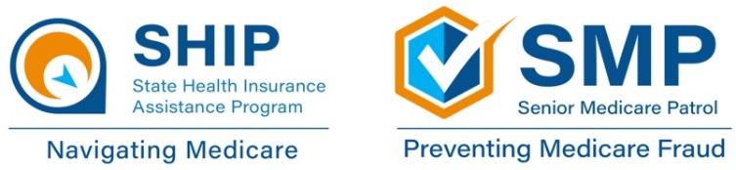

Changing Part D Plans

Medicare Part D, the prescription drug benefit, is the part of Medicare that covers most outpatient prescription drugs. Part D is offered through private companies either as a stand-alone prescription drug plan (PDP) for those enrolled in Original Medicare or as a set of benefits included with the plan for those enrolled in Medicare Advantage.
You should make sure to find Part D coverage that meets your specific health care needs. Before you start looking at plans, make sure you know the prescriptions you take, including their dosages and usual costs and the pharmacies you regularly use.

When can I make changes to my Part D coverage?

Fall Open Enrollment runs from October 15 through December 7, with changes taking effect January 1. You can join a new Medicare Advantage Plan or stand-alone Part D plan (if you have Original Medicare) or switch between Medicare Advantage and Original Medicare (with or without a Part D plan).

The Medicare Advantage Open Enrollment Period (MA OEP) occurs every year from January 1 through March 31, and changes become effective the first of the following month. You can only use this enrollment period if you have a Medicare Advantage Plan. You can use the MA OEP to switch to another Medicare Advantage Plan or to Original Medicare, with or without a stand-alone prescription drug plan.
If you have Extra Help, the federal program that helps pay your out-of-pocket costs for Medicare prescription drug coverage, you can make changes more often. You have Special Enrollment Periods (SEPs) that allow you to enroll in or switch Part D plans once per quarter in the first three quarters of the year.
You may qualify for another Special Enrollment Period. SEPs allow you to change your health and/or drug coverage outside normal enrollment periods. For example, if you move out of your plan’s service area, you would receive an SEP to switch to another plan. There are several SEPs you may be eligible for, so call your local State Health Insurance Assistance Program (SHIP) to learn more. Contact information for your local SHIP is on the last page of this document.
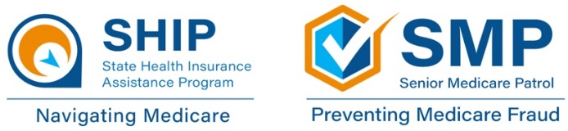

What should I consider when choosing new Part D coverage?

There are many things to consider before choosing a plan, depending on your needs, your financial situation, and your preferences. Some of the following guidelines may be more important to you than others.

- Coverage: First ensure that a plan has your drugs on its formulary. You should also find out if there any restrictions on your covered drugs, such as prior authorization, step therapy, or quantity limits.

- Costs: Medicare’s Plan Finder tool provides a yearly estimate of out-of-pocket costs for each plan you are comparing. You may owe a premium, deductible, and copays.

- Network: You may pay less for your drugs at preferred and in-network pharmacies. If you go to a pharmacy that’s close to your home or easy to get to, it may be beneficial to look for a plan that categorizes that pharmacy as a preferred in-network pharmacy.

- Star rating: Medicare uses a star rating system to measure how well plans perform in different categories. Medicare’s Plan Finder tool includes plans’ star ratings.

New in 2023! It may be helpful for you to know that, starting in 2023, all Part D plans will cover vaccines with no cost to you and will cap your monthly insulin cost at $35.

Quick Tip!
You may find it helpful to use Medicare’s Plan Finder tool, which gives you a list of Medicare Advantage Plans and Part D plans, the drugs they cover, and their estimated costs for the year. You can access Plan Finder by going online to wwww.medicare.gov/plan-compare. You can also contact your local SHIP using the contact information at the end of this document for assistance using the Plan Finder tool.

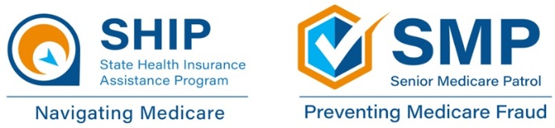

How do I enroll in a new Part D plan?

You can call 1-800-MEDICARE to enroll in your new plan. You should automatically be disenrolled from your previous plan when your new coverage begins. You can also call a plan directly to enroll through a plan representative, but note that it is helpful for Medicare to have the official enrollment record in case there are any problems.

Check your Medicare statements for potential fraud, errors, or abuse

An Explanation of Benefits (EOB) is the statement that your Medicare Advantage Plan or Part D prescription drug plan typically send you after you receive medical services or items. You only receive an EOB if you have Medicare Advantage or Part D. It is important to remember that an EOB is not a bill.

- Your EOB is an explanation of the services and items you have received and how much you may owe for them. It tells you how much your provider billed, the approved amount your plan will pay, and how much you owe the provider.

- EOBs are usually mailed once per month, but some plans give you the option of accessing your EOB online.

- If you keep a record of medical visits, tests, and receipts for services and items received with your SMP My Health Care Tracker, you can compare your EOBs to what you recorded in your tracker.

It is important to read your EOB as soon as you receive it to ensure you actually received all the medications or services listed. If the potential errors are not corrected, contact your Senior Medicare Patrol (SMP). The SMP program empowers and assists Medicare beneficiaries, their families, and caregivers to prevent, detect, and report health care fraud, errors, and abuse.

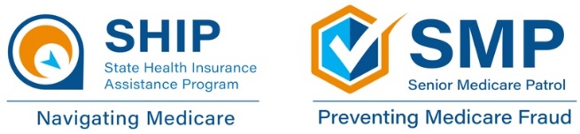
Who to contact for more information

State Health Insurance Assistance Program (SHIP): Contact your SHIP if you have questions about choosing a stand-alone Part D plan (if you have Original Medicare) or a Medicare Advantage Plan. SHIP counselors can also help you use Plan Finder to review your options and pick a plan that meets your needs. When you contact your local SHIP, a certified counselor will give you one-on-one assistance based on your unique situation and needs.

Senior Medicare Patrol (SMP): Contact your SMP if you have experienced potential Medicare fraud, errors, or abuse. SMPs can help and provide you with information to prevent, detect, and report such experiences.

Medicare: Call 1-800-MEDICARE to change Part D or Medicare Advantage Plans.

Medicare Advantage Plan/Part D plan: Contact a plan directly if you have questions about its benefits, coverage, or costs.
Local SHIP contact information | Local SMP contact information
SHIP toll-free: 866-413-5337 | SMP toll-free: 866-413-5337
SHIP email: shineinfo@aaaswfl.org | SMP email: shineinfo@aaaswfl.org
SHIP website: www.floridashine.org | SMP website: www.floridashine.org
To find a SHIP in another state:  Call 877-839-2675 (and say “Medicare”  when prompted) or visit www.shiphelp.org | To find an SMP in another state:  Call 877-808-2468 or visit www.smpresource.org
SHIP Technical Assistance Center: 877-839-2675 | www.shiphelp.org | info@shiphelp.org
SMP Resource Center: 877-808-2468 | www.smpresource.org | info@smpresource.org
© 2022 Medicare Rights Center | www.medicareinteractive.org |

The Medicare Rights Center is the author of portions of the content in these materials but is not responsible for any content not authored by the Medicare Rights Center. This document was supported, in part, by grant numbers 90SATC0002 and 90MPRC0002 from the Administration for Community Living (ACL), Department of Health and Human Services, Washington, D.C. 20201. Grantees undertaking projects under government sponsorship are encouraged to express freely their findings and conclusions. Points of view or opinions do not, therefore, necessarily represent official Administration for Community Living policy.

