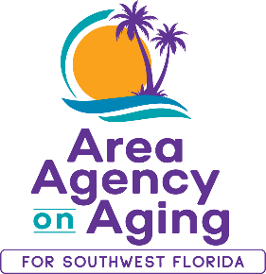 | FOR MORE INFORMATION:  Teresa Estefan  EvClay Public Relations  testefan@evclay.com  305-586-6495

HURRICANE IAN EMERGENCY RESOURCES AND
AREA AGENGY ON AGING FOR SOUTHWEST FLORIDA UPDATE

FORT MYERS, Fla. — September 27, 2022 — As Florida’s west coast prepares for the impact of Hurricane Ian, Area Agency on Aging for Southwest Florida (AAASWFL) wants to ensure that older adults and adults with disabilities in Southwest Florida are connected to needed resources. Our Elder Helpline will continue to be available during regular office hours Monday - Friday, from 8:00 a.m. - 5:00 p.m. at 866-413-5337 or 866-41-ELDER. Our office space will be closed on Tuesday and Wednesday, September 27 and 28, in anticipation of the upcoming storm.

AAASWFL urges local residents to make good use of the 2022 Disaster Resource Guide for Older Adults issued by Florida's Department of Elder Affairs. It includes valuable lifesaving information, including a link to "Know Your Zone" if evacuation becomes necessary. Download it here: https://elderaffairs.org/programs-services/disaster-preparedness/.

If you or someone you love requires a Special Needs Shelter (SpNS) due to physical impairment, mental impairment, cognitive impairment or sensory disabilities, they must register for the Special Needs Shelter Program. For the State of Florida visit: https://snr.flhealthresponse.com/. Registration is only good for one year.

About Area Agency on Aging for Southwest Florida:
Area Agency on Aging for Southwest Florida is a nonprofit organization serving Charlotte, Collier, DeSoto, Glades, Hendry, Lee, and Sarasota Counties. AAASWFL is the state's designated Aging and Disability Resource Center for Southwest Florida. The organization is committed to connecting older adults and adults with disabilities to resources and assistance for living safely with independence and dignity. More information is available at https://www.aaaswfl.org or by calling the toll-free Helpline at 866-41-ELDER.

