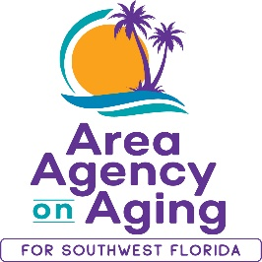
FOR MORE INFORMATION, CONTACT:
Sarah Gualco
Health & Wellness Coordinator
239-652-6914
Sarah.gualco@aaaswfl.org

FOR IMMEDIATE RELEASE
03/08/2022
Commit to Living Healthy!
Join a FREE Workshop to Manage Your Chronic Condition

Southwest, FL (03/08/2022)— 2021 was a challenging year for everyone, and now more than ever, it is important that we learn to take care of our health and well-being. Thankfully, there are free resources available in your community to support Living Healthy in 2022. The Area Agency on Aging for Southwest Florida is offering FREE, virtual workshops for older adults and adults with disabilities who are living with one or more ongoing health conditions, like diabetes, arthritis, pain, cancer, high cholesterol, depression, asthma, heart disease, or high blood pressure.
According to the Florida Department of Health, adults in SWFL are disproportionately hospitalized due to coronary heart disease, diabetes and asthma. However, these chronic illnesses can be successfully managed and their symptoms can be reduced. Part of managing almost any chronic condition involves making lifestyle changes. Our program can assist with developing the skills and confidence to self-manage your chronic health problems.
The Living Healthy workshop is a program to self-manage chronic conditions. Participants develop tools to support healthy nutrition, increase physical activity, manage pain and medication, and build a network of support through the shared experience of living with an ongoing health condition. To register for the next Living Healthy workshop, contact Sarah Gualco at 239-652-6914. This workshop is held virtually via ZOOM and is scheduled for Fridays, 9:30am-12pm, from April 15th to May 20th.
Now is the time to invest in your health!
Space is limited and advance registration is required. To participate, you must reside in Charlotte, Collier, DeSoto, Glades, Hendry, or Sarasota County.

