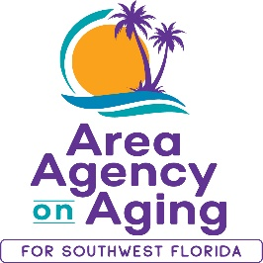
FOR MORE INFORMATION, CONTACT:
Sarah Gualco
Health & Wellness Coordinator
239-652-6914
Sarah.gualco@aaaswfl.org

FOR IMMEDIATE RELEASE
03/14/2022

FREE Fitness Program for People with Arthritis Pain
Register to attend this in-person, evidence-based workshop
with the Area Agency on Aging for SWFL

Southwest, FL (March 14, 2021)— The Area Agency on Aging for Southwest Florida (AAASWFL) is offering a free fitness program to older adults living with arthritis pain or joint stiffness. The Arthritis Foundation Exercise Program is designed to reduce pain and stiffness, restore or maintain joint range of motion, improve balance and coordination, decrease fatigue, increase endurance, and improve overall perceived health status. The program’s gentle exercises can be done either in sitting or standing position.
Starting in April, AAASWFL will offer a free, in-person seven-week AFEP Workshop. This workshop series begins April 4th and continues to May 25th, every Monday & Wednesday from 9:00am to 10:00am, located at Hope Lutheran Church: 25999 Old 41 Road, Bonita Springs.
Since 1984 the Arthritis Foundation Exercise Program within the Aquatic Exercise Association (AEA), has been the proven leader in fitness education. This program provides multiple learning strategies for all aspects of safe and effective fitness programming for arthritis and related conditions, as well as for improved general health and wellness.
Class size is limited and registration is required. To register, contact Sarah Gualco at 239-652-6914, or workshops@aaaswfl.org.

