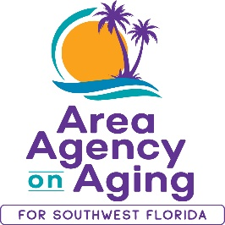
FOR MORE INFORMATION, CONTACT:
Sarah Gualco
Health & Wellness Coordinator
239-652-6914
Sarah.gualco@aaaswfl.org

FOR IMMEDIATE RELEASE
02/21/2022

Free Caregiver Support Program!
Increase Caregiver Knowledge & Skills with this virtual evidence-based workshop offered by the Area Agency on Aging for SWFL

Southwest, FL (February 21, 2022)— Savvy Caregiver, an evidence-based program developed by curriculum authors at Emory University, is a six-week workshop designed to provide caregivers of people with dementia-related illness with the knowledge, skills, and attitudes necessary to manage stress and to execute the caregiving role effectively. Participants will gain personal knowledge and caregiving perspective and will develop skills crucial to assessing the abilities of their person who is living with dementia illness. The workshop focuses on building confidence, setting and altering caregiver goals, and developing strategies to manage the activities of daily living.
Starting in March, the Area Agency on Aging for SWFL (AAASWFL), will offer a free, virtual six-week Savvy Caregiver Workshop. This workshop series begins March 21st and continues to April 25th, every Monday from 1:00pm to 3:00pm on ZOOM.
Space is limited and advance registration is required. To participate, you must reside in Charlotte, Collier, DeSoto, Glades, Hendry, Lee, or Sarasota County. To register, contact Sarah Gualco, AAASWFL’s Health & Wellness Coordinator at sarah.gualco@aaaswfl.org or by calling 239-652-6914.
About Area Agency on Aging for Southwest Florida
The Area Agency on Aging for Southwest Florida is a nonprofit organization that has served Charlotte, Collier, DeSoto, Glades, Hendry, Lee, and Sarasota Counties for more than 40 years. The organization is committed to connecting older adults (ages 60 and over) and people with disabilities to resources and assistance for living safely with independence and dignity. AAASWFL is the state’s designated Aging and Disability Resource Center for Southwest Florida. More information is available by visiting the AAASWFL website (www.aaaswfl.org) or by calling the Elder Helpline: (866) 413-5337.

