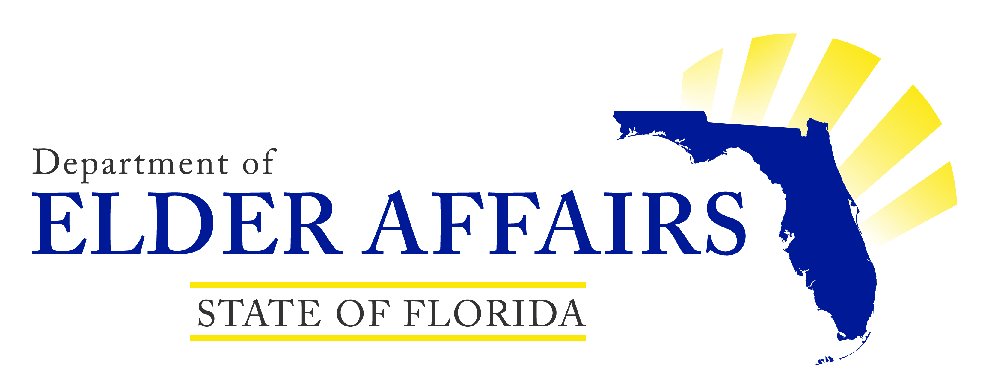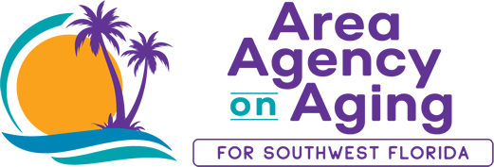

Health and Wellness
Volunteer Instructor Application

Date: Date of Birth (DOB)

Name:
Address:
Phone: E-mail:

Best way to contact me: Phone Email Text

Emergency Contact Name:

Phone:

Gender: female male

What is your race? (Mark all that apply) American Indian or Alaskan Native
Asian or Asian American Black or African American
Hawaiian Native or Pacific Islander White or Caucasian

Are you of Hispanic, Latino, or Spanish origin? Yes
No
Unknown

Age group: Less than 50 yrs. 50 – 54 yrs. 55 – 59 yrs.
60 – 64 yrs. 65 – 69 yrs. 70 – 74 yrs.
75 – 79 yrs. 80 – 85 yrs. Over 85 yrs.

Education:
Some high school High school graduate

Some college or vocational school College graduate
Some graduate school Graduate school

Occupation or life experience:
Hobbies and activities enjoyed:
Other volunteer experiences:

Do you speak more than one language? Yes No
If yes, what language(s):
Do you have transportation? Yes No

How did you hear about our Health and Wellness programs?
Flyer Newspaper Word of mouth Presentation Social Media
Other_________________________________________

Which program(s) are you interested in teaching?

Why are you interested in becoming a volunteer coach/instructor?

My Basic Availability:
I would be available for sessions held:
Monday Tuesday Wednesday Thursday Friday

Best time of day:
Mornings Afternoons
Not sure - please call me when you are scheduling a class

The best location for me is:
Lee County Charlotte County Collier County
Hendry County Glades County Desoto County
Sarasota County Specific Area: ___________________________
Virtually available for all counties

I understand that if I am selected to volunteer, my assignment will be contingent upon a background check

_____________________________ ______________________
Signature Date

