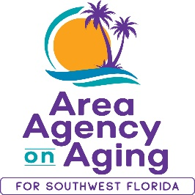

FOR MORE INFORMATION, CONTACT:
Sarah Gualco
Health & Wellness Coordinator
239-652-6914
Sarah.gualco@aaaswfl.org

FOR IMMEDIATE RELEASE
01/12/22

Stay Active this New Year with a FREE Exercise Program!
Register to attend the Arthritis Foundation Exercise Program
with the Area Agency on Aging for SWFL

The Arthritis Foundation Exercise Program is an evidence-based program designed for adults age 60 and over to reduce arthritis pain and stiffness, build muscle around joints, increase energy, and prevent other health problems. The gentle exercises can be done either sitting or standing and help to improve mobility, muscle strength, and coordination, and to reduce fatigue, pain, and stiffness.

Starting in February the Area Agency on Aging for Southwest Florida (AAASWFL), will offer a free Arthritis Foundation Exercise Program (AFEP) in Lee county. The classes will be held at the Wa-Ke Hatchee Recreation Center: 16769 Bass Road, Fort Myers, 33908. AFEP classes will meet on Wednesdays from 1pm to 2pm, February 9th to March 30th.

Space is limited and advance registration is required. To register, contact Sarah Gualco, AAASWFL’s Health & Wellness Coordinator at sarah.gualco@aaaswfl.org or by calling the Elder Helpline toll-free at 866-413-5337 (41-ELDER). Funding for the Arthritis Foundation Exercise Program is provided by the Department of Elder Affairs.

The Area Agency on Aging for Southwest Florida is a nonprofit organization that has served Charlotte, Collier, DeSoto, Glades, Hendry, Lee, and Sarasota Counties for more than 40 years. The organization is committed to connecting older adults (ages 60 and over) and people with disabilities to resources and assistance for living safely with independence and dignity. AAASWFL is the state’s designated Aging and Disability Resource Center for Southwest Florida.
More information is available by visiting the AAASWFL website (www.aaaswfl.org) or by calling the Elder Helpline: (866) 413-5337.

